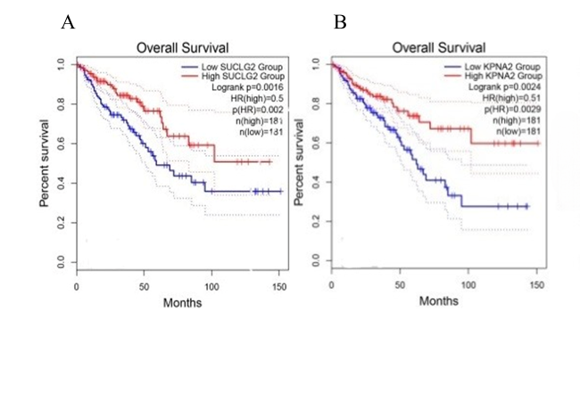 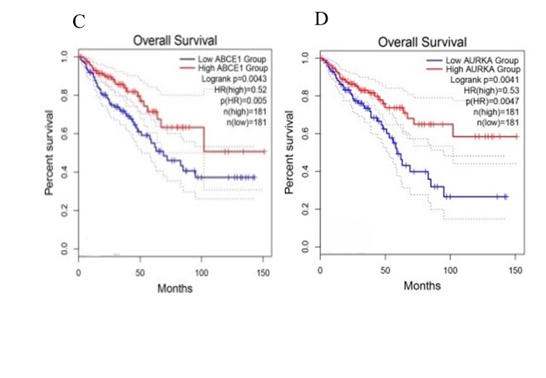 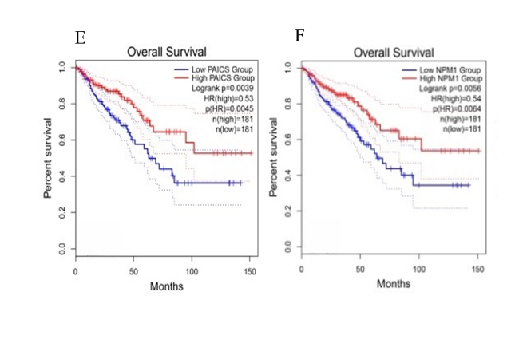 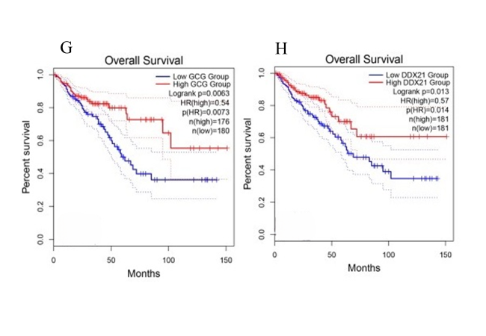 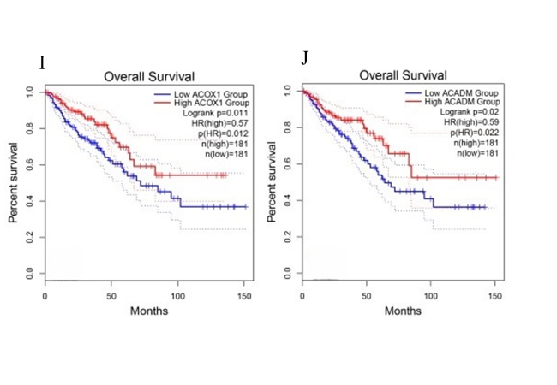 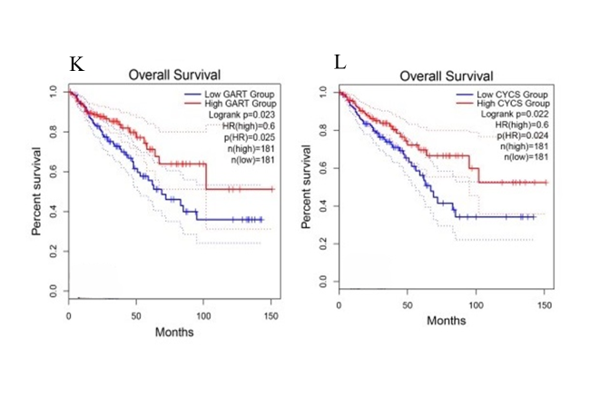 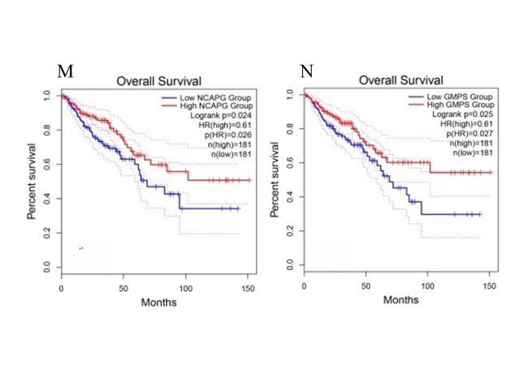 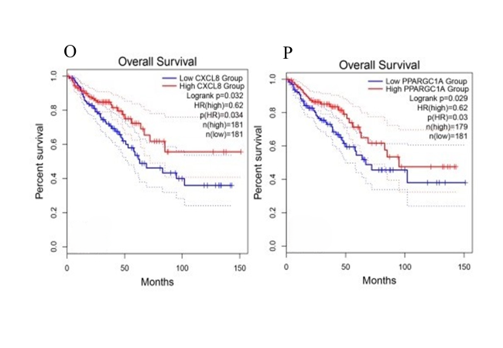 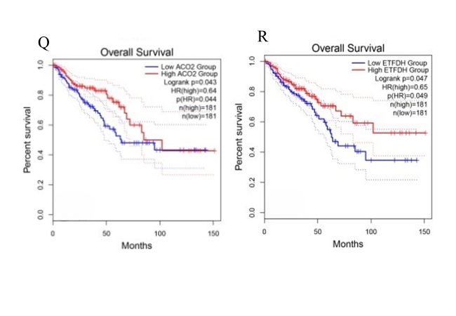 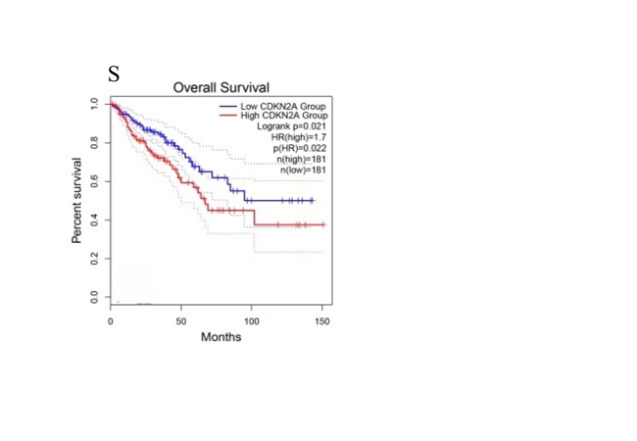 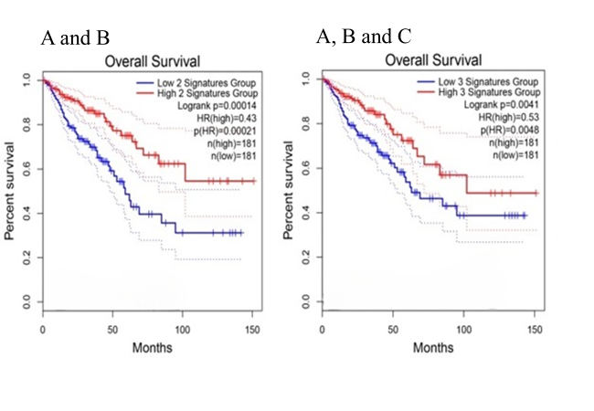 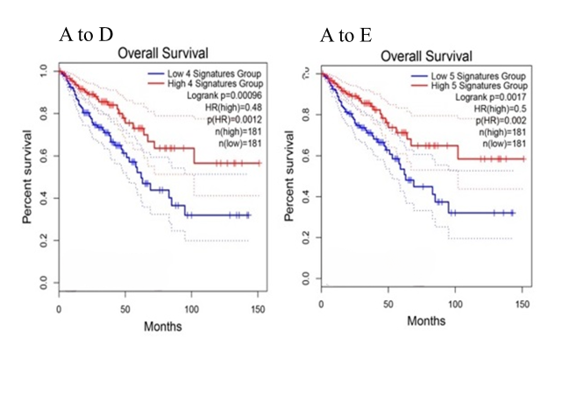 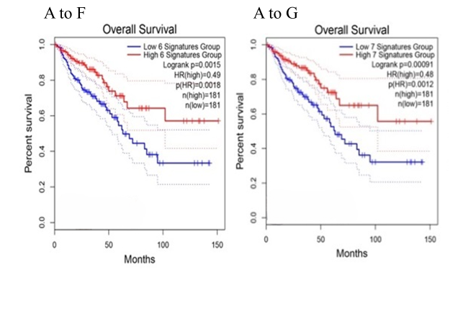 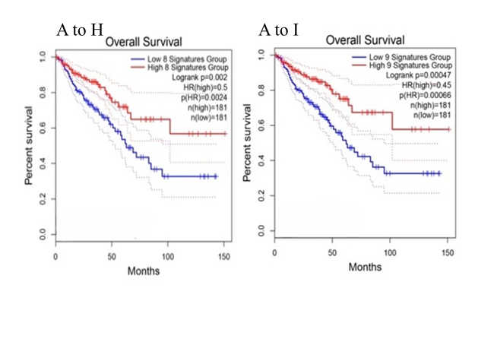 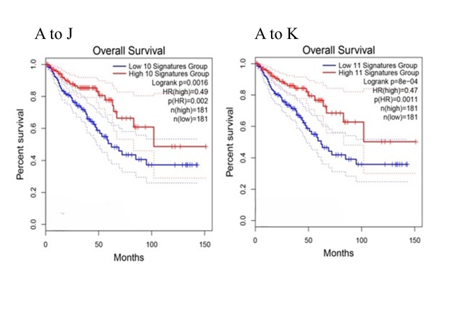 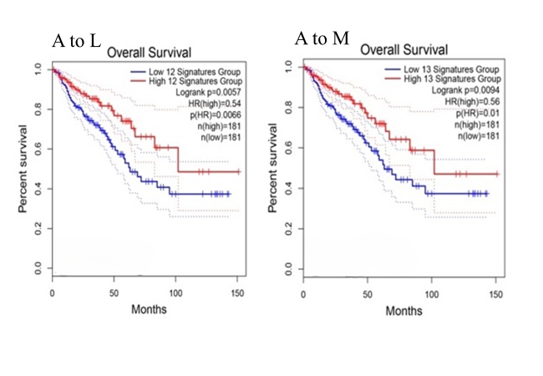 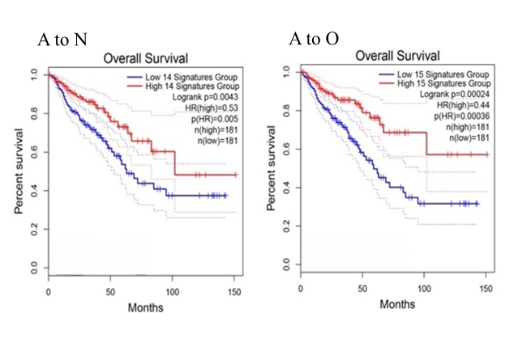 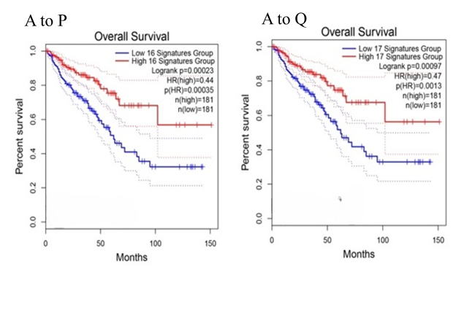 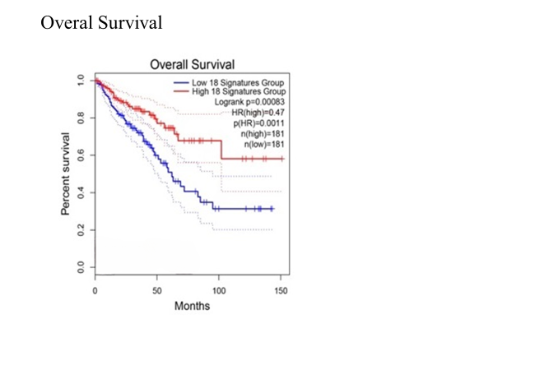

**Supplementary Fig. 1.** The Kaplan-Meier plots demonstrating the correlation between the abnormal expression of the hub genes, different combination of markers, and survival rate in CRC. Blue and red lines exhibit under and over-expressed genes, respectively. The x-axis and y-axis represent the survival time of CRC patients and the probability of survival, respectively. Dotted lines illustrate 95% confidence interval. SUCLG2 (A), KPNA2 (B), ABCE1 (C), AURKA (D), PAICS (E), NPM1 (F), GCG (G), DDX21 (H), ACOX1 (I), ACADM (J), GART (K), CYCS (L), NCAPG (M), GMPS (N), CXCL8 (O), PPARGC1A (P), ACO2 (Q), ETFDH (R), and CDKN2A (S).